26th April 2016

**Stian Paulsen leads new season in the SEAT Leon Eurocup**

The SEAT Leon Eurocup 2016 started its engines at the weekend. The historical “Autodromo do Estoril”, in Portugal hosted the first two races of the new Championship. This year, 17 drivers of 10 different nationalities will compete for the trophy on board the new SEAT Leon Cup Racer.

Japanese tyre manufacturer YOKOHAMA is the Official Tyre partner to the International series which is made up of 7 race weekends visiting some of the world’s most famous race tracks in Portugal, UK, France, Italy, Austria, Germany and Spain.

After the dominance of Mikel Azcona (PCR Sport) who fronted the first race of the weekend from Pole and sped to victory with a very significant difference of over seven seconds over Stian Paulsen (Stian Paulsen Racing), Sunday witnessed the Portuguese circuit of Estoril hosting the second race in the SEAT Leon Eurocup.

With perfect weather conditions it was Stian Paulsen who managed the victory in race 2. Paulsen, was followed by Lucile Cypriano (JSB Competition) and Mauricio Hernández (PCR Sport), second and third respectively and protagonists of an exciting and fiercely competitive head to head. The French lady who had been 7th on Saturday’s race, showed excellent potential for the series with very quick lap times at Estoril.

The Norwegian Stian Paulsen made a spectacular start from sixth on the grid and soon had the lead with just two laps gone. His SEAT Leon Cup Racer was flying but Mauricio Hernández and the young Lucile Cypriano kept reasonably close and lapped in the 1’51s. It was then that Stian Paulsen, at the halfway point of the race that he was able to create some distance with those behind, and eventually crossed the finish line with almost four seconds of advantage over the nearest pursuer.

Thrills galore for the second place in the podium were the order of the day with Lucile Cypriano eventually getting the better over Mauricio Hernández who had to settle for third place.

After a hectic and impressive Sunday in Portugal the Norwegian leads the SEAT Leon Eurocup with 44 points after his second place from the first race and the victory on Sunday. Closely following is Mikel Azcona on 40 points and Lucile Cypriano on 24 points.

Lucile also heads the Ladies Trophy with 20 points.

Race 1 video link;

<https://www.youtube.com/watch?v=9cgF849D9aU>

Race 2 video link;

<https://www.youtube.com/watch?v=kri6JYn0Ydg>

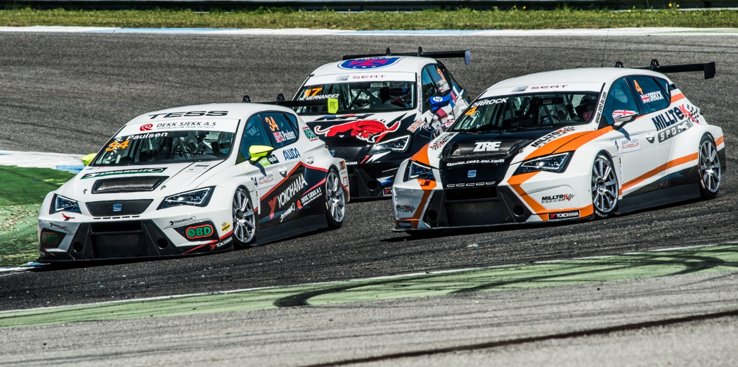

*Stian Paulsen leads after first race weekend of SEAT Leon Eurocup*

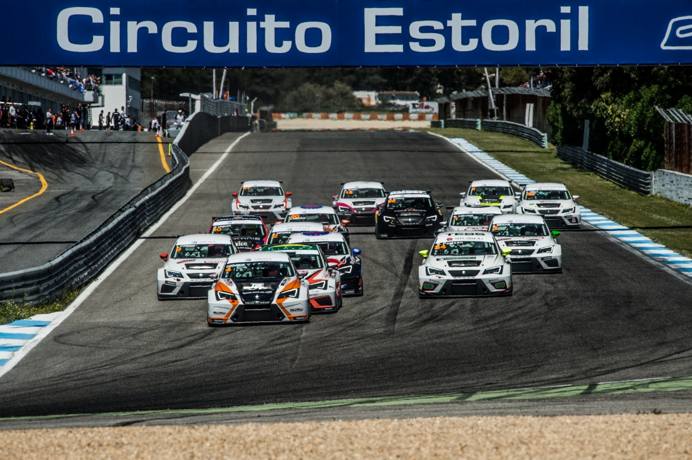

*SEAT Leon Eurocup*